|  |  |  |
| --- | --- | --- |
| Member 1 | Nabh Sanjay Mehta | NSM190002 |
| Member 2 | Anil Kumar Yadav Kare | Axk190056 |
| Class | BUAN 6312.003 | Thursday 4-7PM batch |

**Problem 3: Answers**

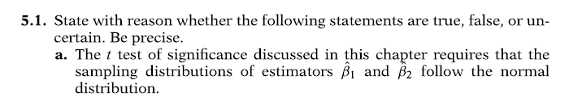

Ans: True. In t-test, variable must be normally distributed. As estimators B1 and B2 are linear functions of disturbance u which is assumed to be normally distributed under CNLRM, these estimators are also normally distributed.



**Ans:** True. No assumptions are required to establish unbiasedness.



**Ans:** True.



**Ans:** True. P value determines the level of significance of whether null hypothesis H0 can be rejected or not. T-test size and p value should mean the same.



**Ans:** True



**Ans:** False. We do not say it is true, but based on the given data we say that we do not reject H0 hypothesis.



**Ans:** False

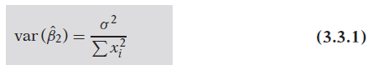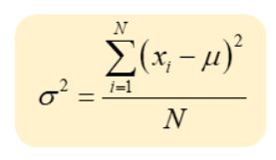

Since both numerator and denominator has x square term, both will offset change fluctuations



**Ans:** False. If both the means are independent, then only it will be equal.



**Ans:** True

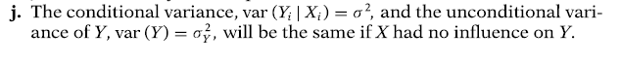 **Ans:** True

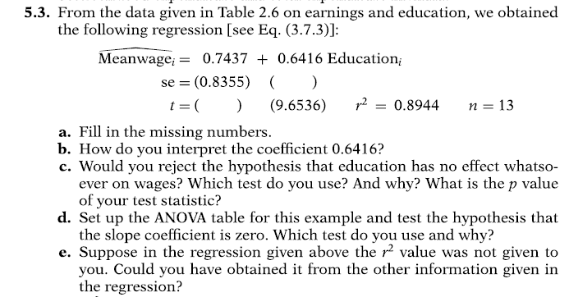

**Ans a) Note – As per LM model used on data provided by professor on eLearning, I’m getting Beta1, Beta2 values as below and not as described in the question.**

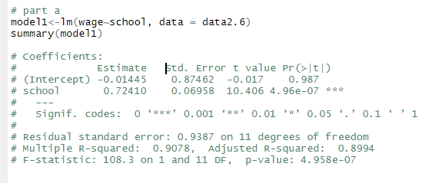

se(school) = 0.72410

t(intercept) = - 0.017

**b)** Interpretation of Beta 1 – For a unit increase in education(school), there is a 0.72 unit increase in wages

**c)** Lets, test the **hypothesis**:

H0: Education has impact on wages (=)

H1: Education has no impact on wages (<>)

If we check the p-value of school in above snapshot, we can see that it is practically zero, and it is insignificant to reject the null hypothesis.

Therefore, we can say that education has impact on wages, and we do not reject null hypothesis.

Similarly, for the question asked, the answer is **Yes, we reject the hypothesis that education has no impact on wages**

**d)**

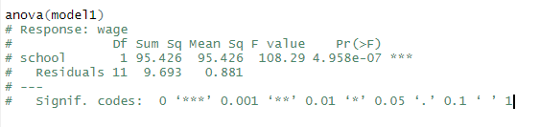

Let’s test the **hypothesis**:

H0: Slope (Beta2) is zero (=)

H1: Slope is not zero (<>)

In above snapshot, p-value for school is practically zero, and it is insignificant to reject the null hypothesis.

**Our verdict is – Beta 2 (school) has impact on wages**

**e)** We can use ANOVA applied on our lm model model1 to derive rsquared value as below

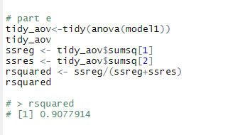

**5.9**

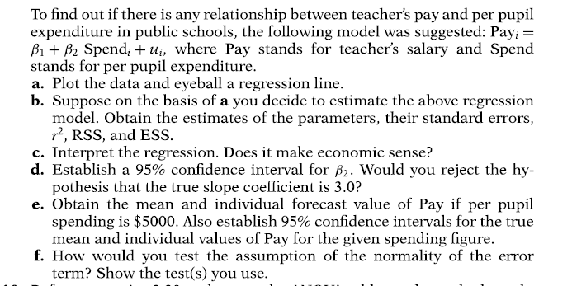

**a)**

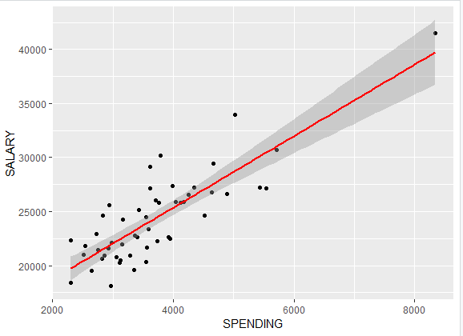

**b)** Details given as below

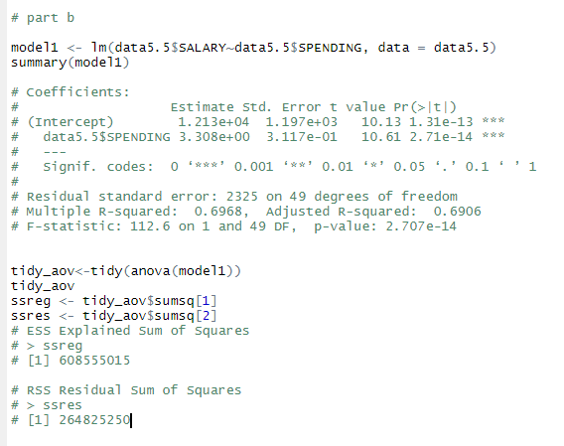

**c)** Given the spending per pupil if increases by dollar, then the average pay increases by about 3.31.

**d)** The 95% Confidence interval is (2.6842, 3.931)

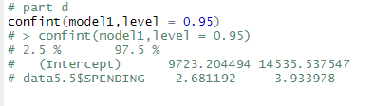

We cannot reject the null hypothesis because UCL for Slope is 3.934.

**e)**

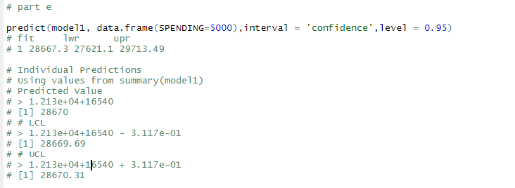

**f)** We performed following plots and test to understand the normality of error terms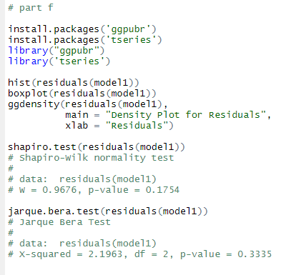

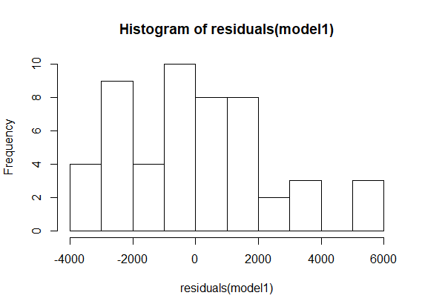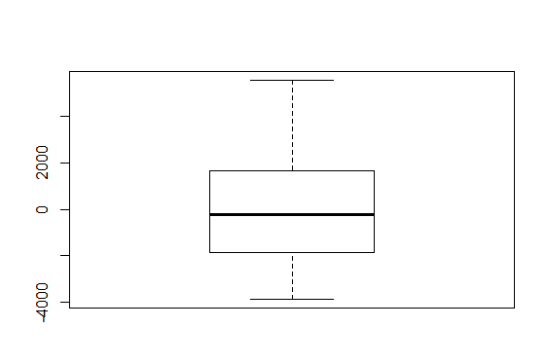 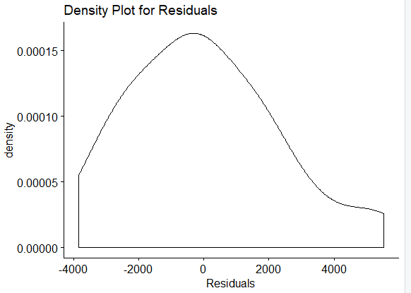

Based on shapiro and Jarque bara test, the p-value suggests that we do not reject null hypothesis.

**6.1)**

True. We know that when X and Y in deviation form, the mean values are always zero. Hence the estimated intercept is also zero.

**6.3)**

**a)** Since the model is linear in parameter, it is linear regression model.

**b)** We need to define Y* = (1/Y)

X* = (1/X)

And do the OLS Regression of Y* on X*.

**c)** As X tends to infinity, Y tends to (1/B1)

**d)** This model is more appropriate when we need to identify consumer purchase patterns. For ex. If a customer has higher income and he/she does not yet prefer to purchase a particular product at Walmart. The reason could be because the product is not adhering to good quality and thought of as not so interesting or inferior good.

**6.4)**

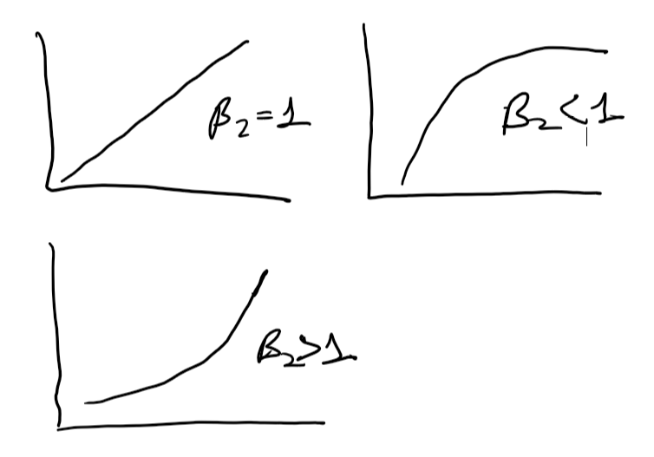

**6.6)**

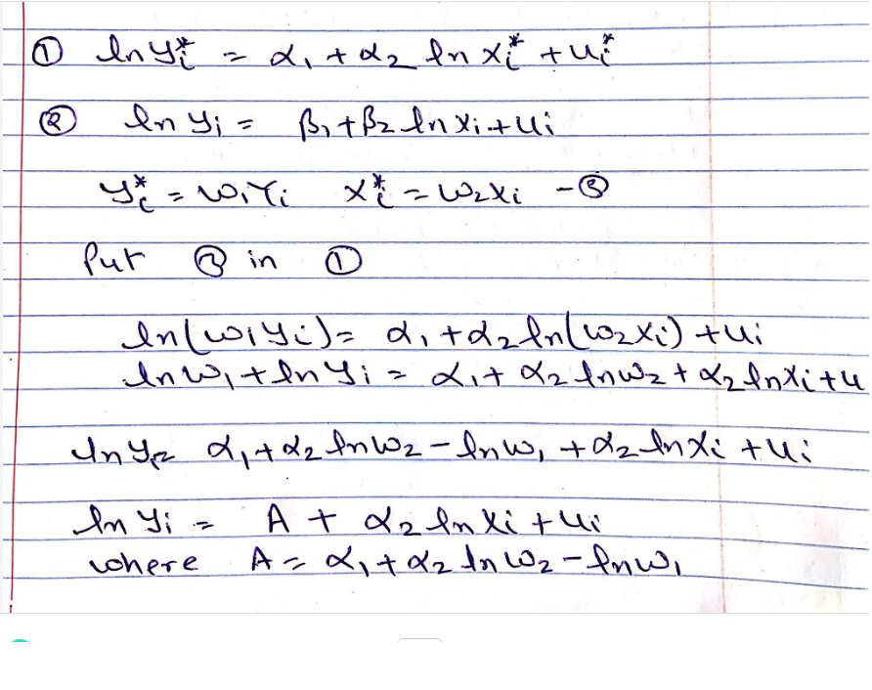

Except intercept A in derived equation, it is same as equation 2. So it is different in estimating intercepts but it will same in estimating slope coefficients.

**b)** The r^2 values for the two models are same.

**6.14)**

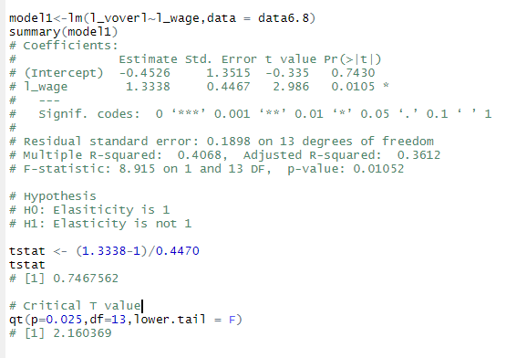

Since t value in above snapshot does not fall in critical t region, we can say that **we do not reject null hypothesis**